Unit 3 – Individual Project NAME: _______________________________ Per. _______

Create An Advertisement!
Persuade others that the way you solve systems of equations is the best way. (Your way might be a combination of the three different methods that we have learned, just explain what you do.)

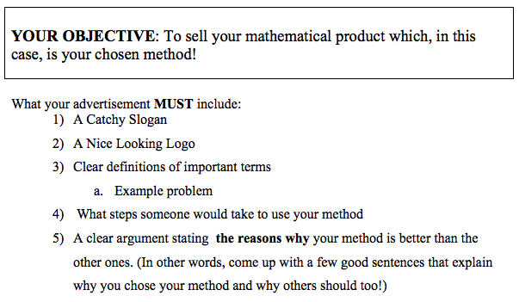

Here is how I will grade the project:
I. Productive participation at all times in class (4 Points)

II. Neatness and Clarity (4 Points)
Is your work legible and neatly presented?
Are your definitions, examples, steps and other parts of the advertisement clearly worded, labeled, and legibly written?

III. Quality of Mathematics (4 Points)
Did you accurately define all math terms?
Did you properly state the steps necessary to use your method?
Are your examples good choices to illustrate the benefits of your chosen method?

IV. Design: Slogan and Logo. (4 Points)
Is your logo and slogan appropriate for your advertisement?
Do your logo and slogan work towards selling your method?

V. Argument (4 Points)
Did you articulate a clear argument for the benefits of using your chosen method?
(See #5 under “What your advertisement MUST include”)

