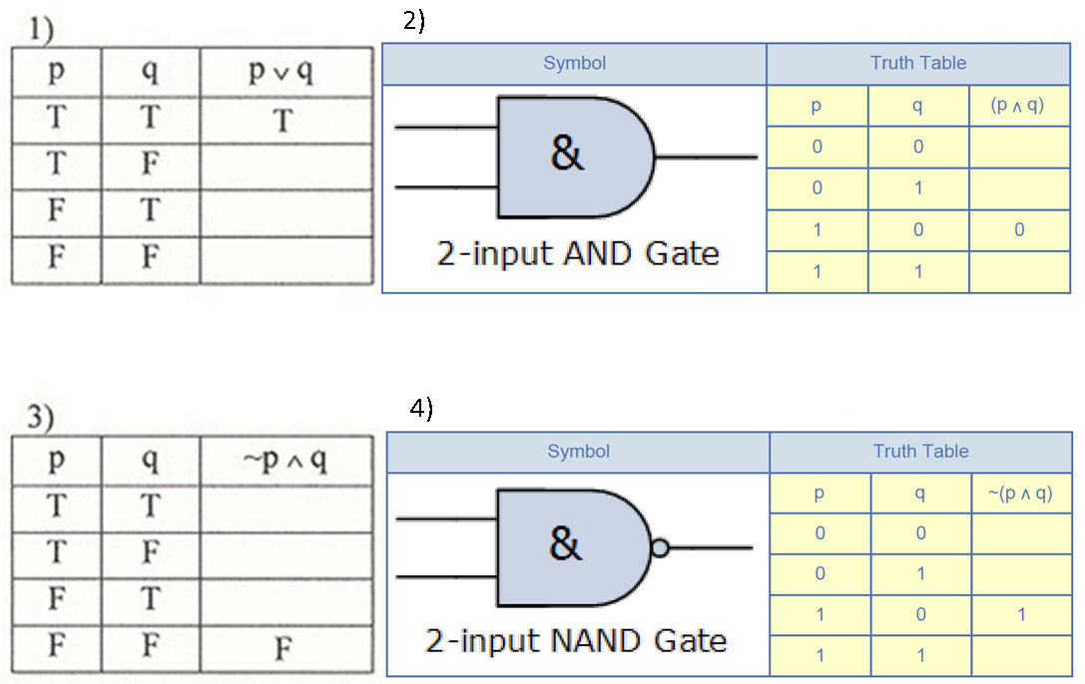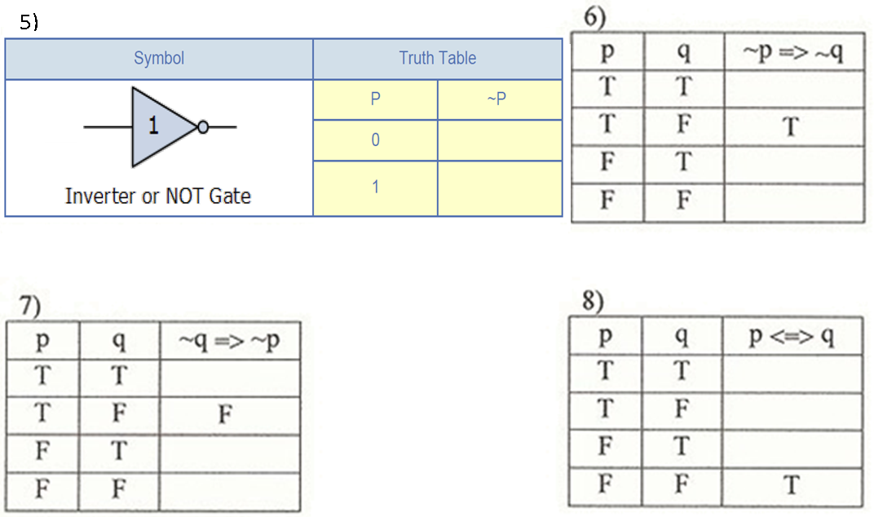Truth Tables and Logic Gates Worksheet
Term Symbol(s) Definitions
Term | Symbol(s) | Definition
and | ^ | Both have to be true for the compound statement to be true
or | v | One or the other or both have to be true for the compound statement to be true
Negation | ~  ¬ | The opposite truth value
Conditional | p=>q  p→q | p implies q, stated as “if…, then…”
Converse | q=>p  q→p  p←q | The order of the hypothesis and conclusion is reversed
Inverse | ~p=>~q  ~p→~q | Both hypothesis and conclusion are negated
Contrapositive | ~q=>~p  ~q→~p | Hypothesis and conclusion are negated and reversed
Biconditional | p<=>q  p↔q | When both a conditional and its converse are true; stated as “if and only if” (or iff)
OR gate: true if either or both inputs are true
AND gate: true if both inputs are true

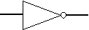
NOT gate: reverses the logic state
NOR gate: true if both inputs are false
NAND gate: false if both inputs are true

